CUSTOMER CHURN PREDICTION IN TELECOM INDUSTRY
(Machine Learning Based Customer Retention System)
Conclusion, Future Scope and References
Department of Computer Science and Engineering, TKR College of Engineering and Technology (Autonomous)
Batch A14 (CSE-A) · Academic year [ACADEMIC YEAR]
Table 1: Project team
S.No. | Student name | Roll number
1 | ANANTULA SAI NIKHILA SRAVANI | 23K91A0512
2 | AVULA ANUDEEP | 23K91A0518
3 | B SANDEEP | 24K915A0503
4 | DARAGANI VINOD KUMAR | 23K91A0558

Project guide: B. SRIKANTH, Assistant Professor, Department of CSE
Chapter and section numbers quoted in the text (for example Section 6.6 or Chapter 8) refer to the full project report, 17.Final Document. Figures and tables in this document are numbered from 1.

CHAPTER 9: CONCLUSION

9.1 Summary of the Work
This project set out to move customer-churn work from a table of classifier metrics to a tool a retention team can use. It built a complete pipeline and application: a data loader that profiles and validates a customer table, a preprocessing pipeline fitted on the training split only, three required and two optional classifiers with class-weight or SMOTE imbalance handling, an evaluation module with five metrics and the usual curves, a risk-banding scheme with editable thresholds, global and per-customer explanations, a what-if analysis, a transparent rule engine that turns drivers into retention suggestions, batch scoring and a drift check. These are delivered through two interfaces on one core: the original Streamlit application and the ChurnIQ web interface served by a FastAPI layer.
On the synthetic sample (1,000 customers, 26.4% churn) the best model by F1 is Logistic Regression: accuracy 0.630, precision 0.385, recall 0.660, F1 0.486 and ROC-AUC 0.722 on a 200-row test split. Cross-validation and repeated splits show that Logistic Regression and Random Forest cannot be separated reliably (F1 0.483 ± 0.055 and 0.463 ± 0.051 in 5-fold cross-validation). Ranking customers by predicted risk and contacting the top 20% reached 39.6% of the churners, a lift of about 2 over random contact.

9.2 Objectives Revisited
Table 2: Outcome against the six objectives
No. | Objective | Outcome | Evidence
1 | Acquire a dataset and explore churn behaviour | Met, with a caveat | A synthetic 1,000-customer data set with the Telco schema is generated (no real operator data); the Explore page and Section 8.2 show churn by contract, tenure, service and payment
2 | Clean, encode and address class imbalance | Met | Duplicate removal, imputation, scaling, one-hot encoding; class weights and SMOTE; recall measured with and without handling (0.1887 against 0.6604 for Logistic Regression)
3 | Train and compare Logistic Regression, Decision Tree and Random Forest | Met | All three trained and compared (plus Gradient Boosting and Histogram Gradient Boosting); Logistic Regression recommended on F1
4 | Evaluate with accuracy, precision, recall, F1 and ROC-AUC | Met | All five metrics, confusion matrices, ROC and precision-recall curves, plus cross-validation and repeated splits
5 | Identify the features that drive churn | Met | Coefficients and permutation importance: contract type, monthly charges, tenure and payment method lead. SHAP not exercised
6 | Present at-risk customers and drivers through a dashboard | Met | Dashboard, risk bands, Customer 360, what-if, retention actions, batch scoring and monitoring pages

9.3 Limitations
The conclusions are limited in the following ways, which are discussed in full in the Scope and Limitations document:
• The data are synthetic. The metrics describe the pipeline on generated data and say nothing about accuracy on a real operator's customers.
• The test split has 200 rows and 53 churners. Cross-validation and repeated splits show spreads of 0.03 to 0.10 on several metrics, and a Random Forest result changes with the scikit-learn version.
• The ranking ability is moderate (ROC-AUC about 0.72, F1 about 0.46-0.51) and the probabilities are not calibrated (Brier score 0.213 against 0.195 for a constant predictor).
• SHAP was not installed, so no SHAP result is reported; the explanations are coefficient-times-value and permutation importance.
• The retention rules are heuristics written by the team. Their effect on real churn was not measured.
• There is no database, no multi-user support and no real authentication; the login is a demonstration.
• No user-acceptance study, load test or non-Chrome browser test was carried out.

9.4 Concluding Remarks
The project shows that an end-to-end churn workflow can be built from open-source parts, run on a desktop in seconds, and made inspectable at every step: the data are profiled, the model is chosen on a metric that is not fooled by imbalance, each score carries its drivers, and each suggestion carries its rule. It follows the motivation of the base paper [1], that churn predictions are most useful when they can be explained, and supplies the application layer the paper leaves open. Its numerical results are a demonstration on synthetic data; the next step, described in Chapter 10, is to repeat the evaluation on real customer records before any retention decision depends on it.
The two figures below summarise the evidence behind the conclusion: the five models side by side, and how many churners a team reaches by contacting customers in order of predicted risk.
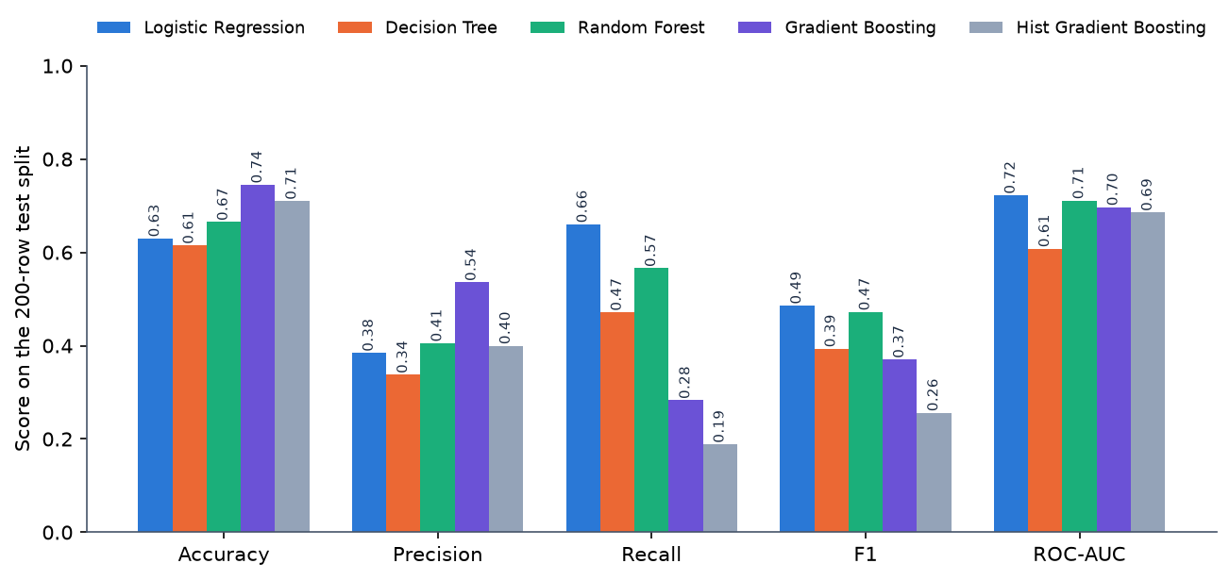
Figure 1: Test-split metrics of the five models (class weights, seed 42)
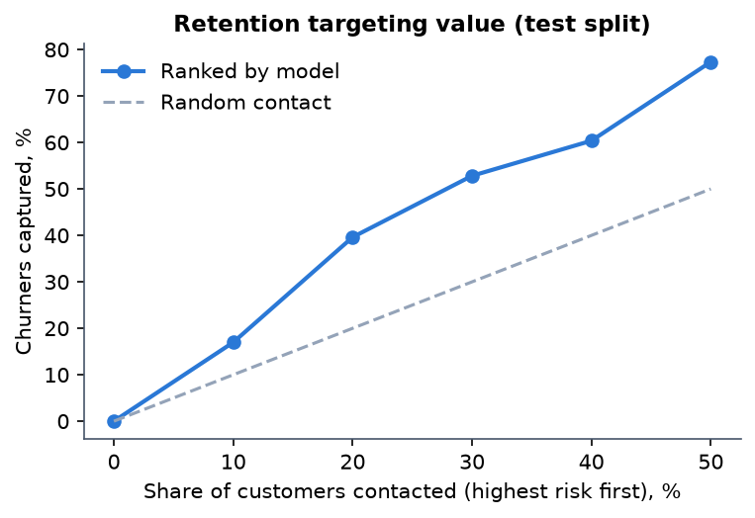
Figure 2: Churners captured when contacting the highest-scored customers first (test split)

CHAPTER 10: FUTURE SCOPE
The work leaves several directions open. They are ordered by how much they would change the value of the system.
1. Validate on real data. Repeat the experiments on real operator data or at least on the real public Telco file (7,043 rows), which the loader already supports after the pandas-3 fix. This would give metrics that can be compared with the base paper under a stated protocol, a much larger test set, and an honest answer to whether the synthetic-data conclusions hold.
2. Calibrate the probabilities. Apply Platt scaling or isotonic regression on a validation split so that a score of 60 can be read as a chance of about 60%, and report reliability curves and the Brier score as part of the Evaluation page.
3. Add SHAP and the base paper's explainers. Install and test the SHAP code path that already exists, compare it with the permutation and coefficient explanations, and implement LIME and a unified perturbation explainer in the manner of the base paper to compare fidelity, consistency and runtime on the same models.
4. Stronger models and tuning. Add XGBoost, LightGBM and CatBoost, tune hyper-parameters by cross-validation, and keep Logistic Regression as the interpretable baseline. Evaluate on cross-validation first, given the noise of a single split.
5. Cost-sensitive decisions. Let the analyst enter the cost of an offer and the value of a retained customer, choose the decision threshold that maximises expected profit, and show the expected return of contacting the top k%.
6. Measure the retention rules. Run a controlled campaign (offer against no offer) on a sample of high-risk customers to estimate uplift, and refine or retire the rules according to measured effect.
7. Time and behaviour. Use usage, complaint and billing histories over time (survival analysis or sequence features) so that churn can be predicted months ahead and not only from a snapshot.
8. Production foundations. Replace the in-memory state by a database, add real accounts with roles and an audit log, store models with versions, and add scheduled batch scoring and statistical drift tests (population stability index, Kolmogorov-Smirnov).
9. Integration. Expose scores to a CRM through the API, and containerise the services for deployment.
The first three are the most important: they address the main weakness of this report (synthetic data), the main weakness of the scores (calibration) and the main gap against the base paper (explanation methods).

REFERENCES
[1] S.-V. Oprea and A. Bara, "Explaining customer churn through unified perturbation-based XAI soft computing," IEEE Access, vol. 14, pp. 24460-24478, 2026, doi: 10.1109/ACCESS.2026.3663648.
[2] A. Sikri, R. Jameel, S. M. Idrees and H. Kaur, "Enhancing customer retention in telecom industry with machine learning driven churn prediction," Sci. Rep., vol. 14, no. 1, 2024, doi: 10.1038/s41598-024-63750-0.
[3] A. El Attar and M. El-Hajj, "Explainable AI-driven customer churn prediction: a multi-model ensemble approach with SHAP-based feature analysis," Front. Artif. Intell., vol. 9, Feb. 2026, doi: 10.3389/frai.2026.1748799.
[4] H. A. Rasool, K. K. Aljawaheri and A. A. M. Karram, "Explainable customer churn prediction in telecom using ensemble learning and SHAP analysis," Math. Model. Eng. Probl., pp. 4373-4386, Dec. 2025, doi: 10.18280/mmep.121226.
[5] A. K. Ahmad, A. Jafar and K. Aljoumaa, "Customer churn prediction in telecom using machine learning in big data platform," J. Big Data, vol. 6, no. 1, Mar. 2019, doi: 10.1186/s40537-019-0191-6.
[6] T. Vafeiadis, K. I. Diamantaras, G. Sarigiannidis and K. Ch. Chatzisavvas, "A comparison of machine learning techniques for customer churn prediction," Simul. Model. Pract. Theory, vol. 55, 2015.
[7] S. M. Lundberg and S.-I. Lee, "A unified approach to interpreting model predictions," in Proc. Adv. Neural Inf. Process. Syst. (NeurIPS), vol. 30, 2017.
[8] M. T. Ribeiro, S. Singh and C. Guestrin, "'Why should I trust you?': Explaining the predictions of any classifier," in Proc. 22nd ACM SIGKDD Int. Conf. Knowl. Discovery Data Mining, 2016, pp. 1135-1144, doi: 10.1145/2939672.2939778.
[9] D. Slack, S. Hilgard, E. Jia, S. Singh and H. Lakkaraju, "Fooling LIME and SHAP: Adversarial attacks on post hoc explanation methods," in Proc. AAAI/ACM Conf. AI, Ethics, Soc., 2020, doi: 10.1145/3375627.3375830.
[10] S. M. Lundberg et al., "From local explanations to global understanding with explainable AI for trees," Nature Mach. Intell., vol. 2, no. 1, pp. 56-67, Jan. 2020, doi: 10.1038/s42256-019-0138-9.
[11] N. V. Chawla, K. W. Bowyer, L. O. Hall and W. P. Kegelmeyer, "SMOTE: Synthetic minority over-sampling technique," J. Artif. Intell. Res., vol. 16, pp. 321-357, 2002, doi: 10.1613/jair.953.
[12] H. He and E. A. Garcia, "Learning from imbalanced data," IEEE Trans. Knowl. Data Eng., vol. 21, no. 9, pp. 1263-1284, Sep. 2009.
[13] L. Breiman, "Random forests," Mach. Learn., vol. 45, no. 1, pp. 5-32, Oct. 2001, doi: 10.1023/A:1010933404324.
[14] F. Pedregosa et al., "Scikit-learn: Machine learning in Python," J. Mach. Learn. Res., vol. 12, pp. 2825-2830, 2011.
[15] C. K. Leung, A. G. M. Pazdor and J. Souza, "Explainable artificial intelligence for data science on customer churn," in Proc. IEEE 8th Int. Conf. Data Sci. Adv. Anal. (DSAA), Oct. 2021, pp. 1-10, doi: 10.1109/DSAA53316.2021.9564166.
[16] J. Mohajon and A. S. Mohammad Arif, "Churn prediction with explainability for the customers of telecom industry," in Proc. Int. Conf. Inf. Commun. Technol. Sustain. Develop. (ICICT4SD), Sep. 2023, pp. 179-183, doi: 10.1109/ICICT4SD59951.2023.10303395.
[17] D. Y. C. Wang, L. A. Jordanger and J. C.-W. Lin, "Explainability of leverage points exploration for customer churn prediction," in Proc. IEEE Int. Conf. Big Data (BigData), Dec. 2023, pp. 5997-6004, doi: 10.1109/BigData59044.2023.10386857.
[18] M. Szelag and R. Slowinski, "Explaining and predicting customer churn by monotonic rules induced from ordinal data," Eur. J. Oper. Res., vol. 317, no. 2, pp. 414-424, Sep. 2024, doi: 10.1016/j.ejor.2023.09.028.
[19] IBM, "Telco customer churn," sample data set (7,043 customers, 21 columns), distributed through Kaggle; also used in [1] and [3].
[20] J. H. Friedman, "Greedy function approximation: A gradient boosting machine," Ann. Statist., vol. 29, no. 5, pp. 1189-1232, 2001.
[21] S. Ramirez, "FastAPI documentation," https://fastapi.tiangolo.com (framework used for the API layer).

